11 Brands Turn to Twitter for World AIDS Day Awareness
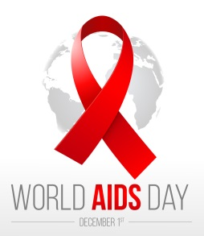
Brands across the country turned to social media to raise awareness for World AIDS Day on Dec. 1. Doctors Without Borders released a music video highlighting AIDS awareness in the Democratic Republic of Congo, while Coca-Cola helped with medical donations to communities in Africa through its Project Last Mile.
PRWeek 12/1/17
https://www.prweek.com/article/1451832/11-brands-marking-worldaidsday-twitter
Image credit:
https://ebpcooh.org.uk/wp-content/uploads/WorldAIDSDay.jpg

