The 1996 Telecom Act - 20 Years Later
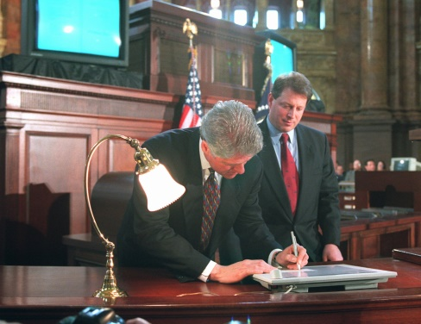
There are those that believe deregulation and consolidation ruined radio, homogenized its sound and killed jobs. Others still argue that more deregulation is needed and national scale is important for radio to compete with more competition for the eyes and ears of the consumer than ever before.
RadioInk 12.23.15
http://www.radioink.com/Article.asp?id=2993060&spid=24698

