2018 Mobile Marketing Predictions from 18 Industry Veterans
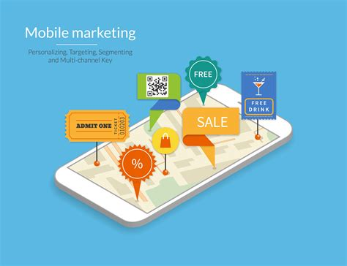
The penetration of smartphone usage in the US among millennials hit 93.1 percent, according to eMarketer. GenXers were close behind at 85.1 percent, with Baby Boomers still lagging significantly at 64.4 percent. (No wonder they’re still writing checks at the checkout line of the grocery store.) In the shocking/not shocking column, Gartner confirmed that 99.6 percent of all new smartphones shipped in the world are run on either Android or iOS.
Marketing Land 1.11.18
https://marketingland.com/2018-mobile-marketing-predictions-18-industry-veterans-231312?utm_source=API+Need+to+Know+newsletter&utm_campaign=933556e4a6-EMAIL_CAMPAIGN_2018_01_12&utm_medium=email&utm_term=0_e3bf78af04-933556e4a6-31697553
Image credit:
https://www.bing.com/images/search?view=detailV2&ccid=HZIYn4xh&id=6F4C18BD4C848CD81139CDFC6D3C18ABF58C01BC&thid=OIP.HZIYn4xhkKj9xXAyYRidMwHaFs&mediaurl=http%3a%2f%2fwww.absolutemobilesolutions.com%2fwp-content%2fuploads%2f2015%2f12%2fshutterstock_245444935.jpg&exph=3846&expw=5000&q=mobile+marketing&simid=608041769132230370&selectedIndex=17&ajaxhist=0

