2020 Political Ad Spend Estimate Rises To Near $11B
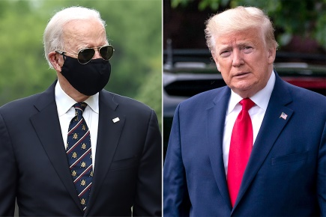
The 50% increase over the $6.5 billion total in 2016 would be another political advertising election record, according to the group. The CRP operates OpenSecrets.org, a resource for federal campaign contributions, lobbying data and analysis. Looking at the presidential campaign only, the group projects $5.2 billion in overall political advertising spend.
Media Post 10.1.20
https://www.mediapost.com/publications/article/356455/2020-political-ad-spend-estimate-rises-to-near-11.html?utm_source=Listrak&utm_medium=Email&utm_term=Political+Ad+Spend+Estimate+Rises+To+Near+%2411B&utm_campaign=How+Media+Covered+Trump+Coronavirus+News
Image credit:
https://imagesvc.meredithcorp.io/v3/mm/image?url=https%3A%2F%2Fstatic.onecms.io%2Fwp-content%2Fuploads%2Fsites%2F20%2F2020%2F05%2F26%2Ftrump-biden.jpg

