2021 Predictions for the Top Social Platforms
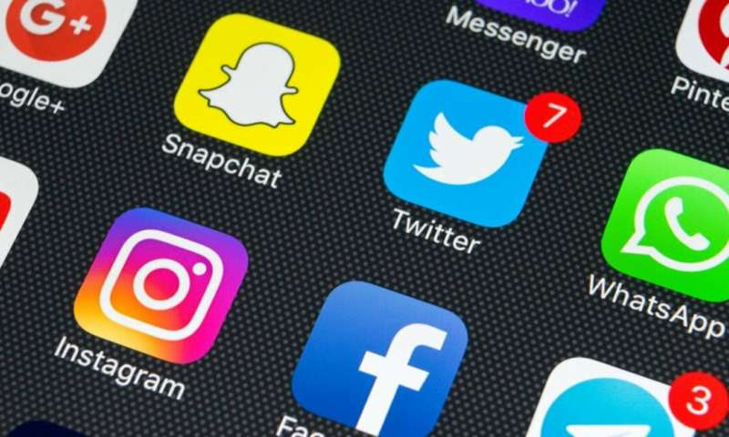
Facebook will focus on e-commerce, merging messaging across apps, augmented reality glasses, virtual reality and algorithm tweaks in 2021, Andrew Hutchinson writes. He also sets out detailed 2021 predictions for Twitter, Instagram, Snapchat, TikTok and LinkedIn.
Social Media Today 11/30/20
https://www.socialmediatoday.com/news/25-predictions-for-social-media-marketing-in-2021/589785/
Image credit:
https://3c1703fe8d.site.internapcdn.net/newman/csz/news/800/2019/fourwayssoci.jpg

