2 College Students Leading the Diversity, Inclusion Charge
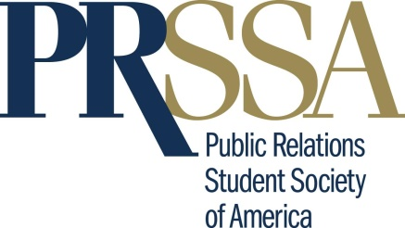
Rayna van Beuzekom and Alyssa Gormley are actively involved in Public Relations Student Society of America and diversity and inclusion initiatives at the University of Florida and Ohio University. They discuss their local efforts and the importance of diversity and inclusion topics in the classroom and note, "[w]e need to make sure we continue to embrace change and encourage others to 'do the right thing' by learning about each other's backgrounds and exposing ourselves to new stories, inside the classroom and out."
PR Daily 11.5.20
https://www.prdaily.com/how-future-communicators-are-embracing-dei-in-prssa-chapters/

