FCC: 39 Stations Still Off the Air After Irma's Destruction
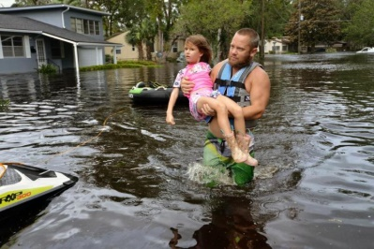
The Federal Communications Commission has reported that radio stations are slowly returning to the airwaves after Hurricane Irma, with just 39 stations off the air as of Wednesday. The FCC's disaster reporting system update also found that 10 TV stations were dark, while 8.2 million cable subscribers were still without service.
Inside Radio 9/13/17
http://www.insideradio.com/free/slowly-but-surely-dark-stations-return-after-irma/article_c209a722-98ca-11e7-97d6-9bd4ebac9a34.html
Image source:
http://assets.nydailynews.com/polopoly_fs/1.3494056.1505340946!/img/httpImage/image._gen/derivatives/article_750/aptopix-irma-98883-jpg.

