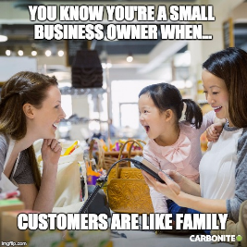
5 Tips For Creating Memorable, Shareable Memes
Yepp CEO Denis Litvinov offers five tips for creating memes that generate engagement and spark social sharing. Sharing memes on social media is especially popular with millennials and Gen Z.
Entrepreneur 9/22/22
https://www.entrepreneur.com/growing-a-business/how-to-use-memes-to-transform-your-marketing-strategy/435351
Image credit:
https://www.carbonite.com/globalassets/images/sections/blog/blog-images/small-business-owner-meme-2.jpg

