5 Ways to Prepare for a Cookieless Future
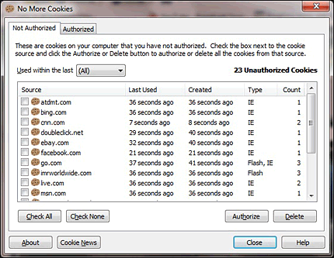
Digilant CEO Raquel Rosenthal offers a five-step plan to help marketers prepare for Google's ban on third-party cookies. She encourages brands to leverage "media mix modeling," centralize data via a customer data platform, stay up-to-date on alternatives and boost investment with major platforms such as Amazon and Facebook to access more data insights.
SmartBrief/Marketing 5.8.20
https://www.smartbrief.com/original/2020/05/5-step-path-cookieless-digital-marketing?utm_source=brief
Image credit:
https://www.cnetfrance.fr/i/edit/2010/pr/11/extension-ie-nomorecookies.png

