5G Let Me Drive a Vehicle from 60 Miles Away
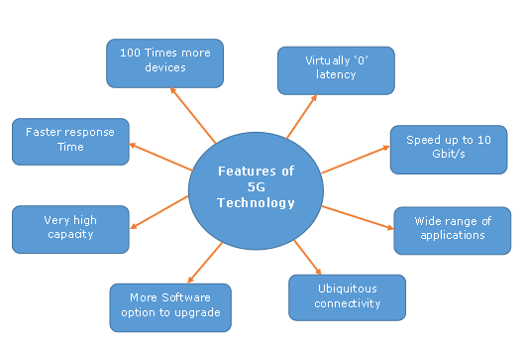
I got to do this because Ericsson let me take its 5G-controlled vehicle-of-sorts (it wasn't a car) for a spin at Mobile World Congress in Barcelona. I was placed in an arcade-like car seat with my only instructions, "It's like a car -- Just drive."
Advertising Age 3.1.17
http://adage.com/article/digital/ericsson-drive-5g-controlled-vehicle-mobile-world-congress/308138/?utm_source=daily_email&utm_medium=newsletter&utm_campaign=adage&ttl=1489019537&utm_visit=113450
Image source:
http://www.tutorialspoint.com/5g/images/salient_features_5g.jpg

