Report: How 5G Can Enhance Video, VR Experiences
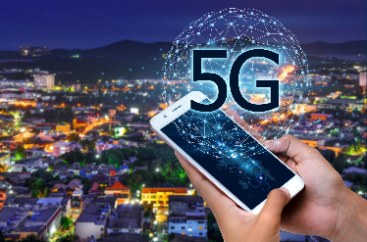
A report from research firms InterDigital and Futuresource Consulting says the spread of 5G technology will lead to numerous benefits, including consistent, high-quality video that is cost-effectively delivered, seamless trips to the metaverse, and using video for non-entertainment experiences. "The challenge now is for industry to develop new audio-visual experiences that can happen 'only on 5G,' " says Futuresource principal analyst Simon Forrest.
MediaPost Communications (free registration) 5.3.22
https://www.mediapost.com/publications/article/373530/how-5g-will-transform-video-within-5-years.html?edition=126138
Image credit:
https://cdn-images-1.medium.com/max/1600/1*tLmHEZkax4BRAt3y2unrwA.jpeg

