5G The Next Gen Mobile
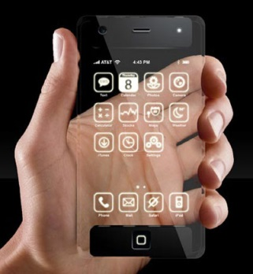
By early next decade, marketers hope 5G speeds will fully realize big ideas like autonomous cars, connected homes and smart cities, not to mention smaller but potent tactics like letting shoppers virtually try on clothes. The arrival of 5G may also finally bring millions of rural consumers into the high-speed data lanes where marketers increasingly sell their products.
Advertising Age 3.6.17
http://adage.com/article/news/5g-gen-mobile/308148/?utm_source=daily_email&utm_medium=newsletter&utm_campaign=adage&ttl=1489357336&utm_visit=113450
Image source:
http://latestmobiletechnology.com/wp-content/uploads/2010/12/iphone5g.jpg

