5G Will Blur the Line Between Physical and Digital Retail
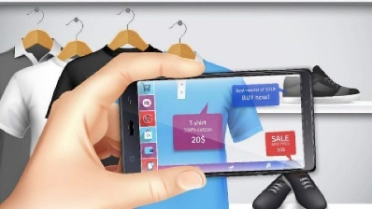
Retailers will invest in 5G to enhance the customer experience, both in-store and online. AR/VR applications and payment systems will be beneficiaries on the customer side. Store operations like inventory management and fulfillment will be bolstered by investments in store data/analytics and internet of things (IoT) systems, including computer vision systems.
eMarketer 3.28.21
https://www.emarketer.com/content/5g-will-blur-line-between-physical-digital-retail?ecid=NL1016
Image credit:
https://www.ednasia.com/wp-content/uploads/sites/3/2021/01/KaushalNaik_einfochips_AR.jpg?w=960

