7 Steps to Creating A Compelling E-Mail Newsletter
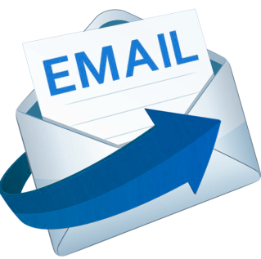
E-mail newsletters are a great push marketing tool that gives a brand a "direct line of communication with customers who willingly agree to stay updated on your business's news," writes Stephanie Vermillion. She offers a step-by-step guide to help PR pros establish a newsletter strategy and execute production.
Strategies & Tactics 10/2019
https://www.prsa.org/article/open-season-how-to-launch-and-sustain-an-e-newsletter
Image credit:
http://worldofdtcmarketing.com/wp-content/uploads/2017/05/email-logo.png

