90 Additional Networks Come to MobiTV Connect
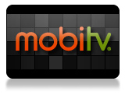
Digital TV provider MobiTV has added 90 networks -- including Bloomberg Television, Discovery and Univision -- to MobiTV Connect, its subscription branded TV app service. The company says the growth of smart TVs and connected platforms including Roku and Amazon Fire TV has contributed to its growth.
MediaPost Communications 9/20/18
https://www.mediapost.com/publications/article/325397/mobitv-adds-90-networks-for-app-based-pay-tv.html

