A Close Look At Dove's Real Beauty Campaign
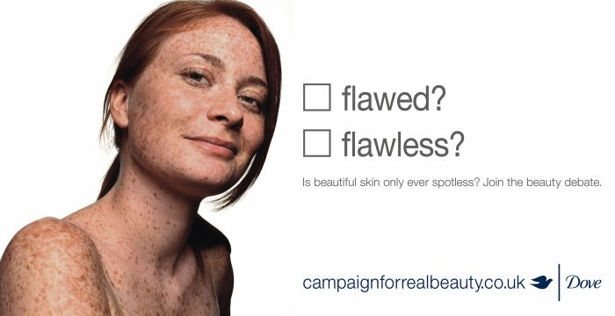
In this video, Marketing Week's Mark Ritson takes a close look at Dove's Real Beauty campaign. His case study highlights how Dove used market research and a "jeweled communications model" to help craft promotions, boost brand equity and increase sales.
Marketing Week (UK) 6/24/19
https://www.marketingweek.com/2019/06/24/mark-ritson-dove-real-beauty-campaign/?ct_5d124abdf28ad=5d124abdf28ae
Image credit:
https://laughloveliveitall.files.wordpress.com/2013/04/dove-campaign-for-real-beauty-1615.jpg

