A DVR Milestone for Broadcast Viewership
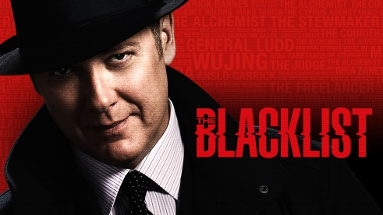
Two Big Four programs drew as many time-shifted viewers as live. This past season, TV viewers were just as likely to be watching “The Blacklist” or “Quantico” time-shifted via DVR within a week of its original airing as watching it live. According to just-released full-season data from Nielsen, NBC’s “Blacklist” and ABC’s “Quantico” both doubled their live-plus-same-day (L+SD) ratings among adults 18-49 when seven-day viewing (L+7) was added.
MediaLife 6.15.16
http://www.medialifemagazine.com/dvr-milestone-broadcast-viewership/

