A Look Ahead at Net Neutrality Changes
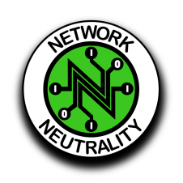
The end of internet neutrality will bring profound changes to the online world, although they're likely to be spread over years. Makena Kelly looks at the implications, including throttling of certain content by providers, and how neutrality advocates plan to mount their opposition through state legislatures and the courts.
The Verge 6/11/18
https://www.theverge.com/2018/6/11/17439456/net-neutrality-dead-ajit-pai-fcc-internet

