A Man Played ‘Pokémon Go’ in a Russian Church
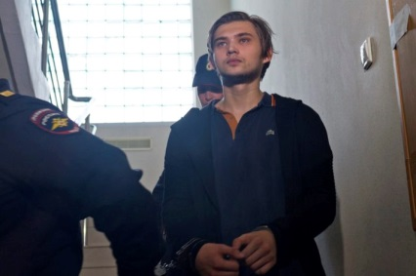
After Russian officials discovered the footage, Sokolovsky was detained last fall and charged with inciting religious hatred. On Friday, the last day of the trial, prosecutors in Russia requested a sentence of 3½ years in prison for Sokolovsky.
The Washington Post 5.1.17
https://www.washingtonpost.com/news/worldviews/wp/2017/04/30/a-man-played-pokemon-go-in-a-russian-church-he-may-spend-3-12-years-in-prison-for-it/?utm_term=.eec51ffcf947

