A Mattel First: A Boy is Featured in an Ad for Barbie
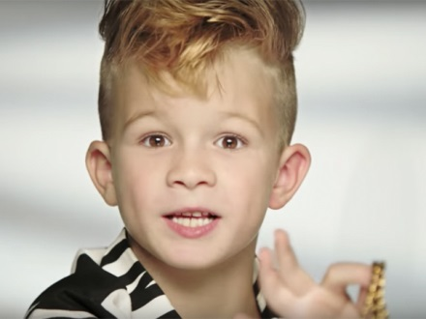
Mattel’s new spot for Moschino-designed Barbie stars a young boy with a faux-hawk haircut playing with the dolls alongside two girls. The boy yells "Moschino Barbie is so fierce!" into the camera. The spot marks the first time Mattel has featured a boy in a Barbie commercial, which is part of its effort to move away from stereotypical advertising.
Digiday.com 11/16/15
http://digiday.com/brands/barbies-moschino-ad-features-fierce-little-boy-first-time/

