ABC News Suspends Ross Over Flynn Gaffe
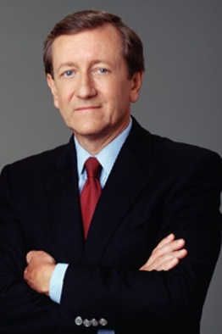
ABC News has suspended anchor Brian Ross for four weeks without pay following an on-air error the journalist made on Friday in which he reported that Donald Trump had instructed Michael Flynn to make contact with the Russians during the 2016 presidential campaign. "It is vital we get the story right and retain the trust we have built with our audience — these are our core principles. We fell far short of that [Friday]," the network said in a statement.
The Hollywood Reporter 12.4.17
https://www.hollywoodreporter.com/news/abc-news-suspends-brian-ross-four-weeks-michael-flynn-gaffe-1063780
Image credit:
https://media2.fdncms.com/csindy/imager/brian-ross-respectable-journalist/u/slideshow/2529339/1342825719-brian_ross.jpg

