Controller Launching For Gamers With Disabilities
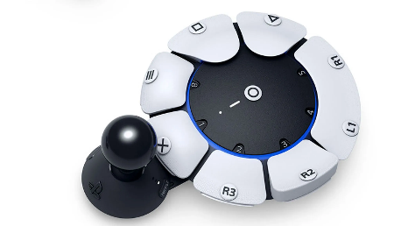
Sony Interactive Entertainment's Access controller, available for pre-order and releasing Dec. 6, is marking a significant step for inclusivity in gaming for people with disabilities. Priced at about $90, the highly customizable device is touted as addressing diverse mobility needs to allow gamers to play more comfortably and participate more fully in the social environment of gaming.
CNN 11.25.23
https://www.cnn.com/2023/10/24/tech/sony-playstation-access-controller-gaming-disabilities/index.html
Image copyright:
https://i0.wp.com/www.techdigest.tv/wp-content/uploads/2023/01/skynews-ps5-gaming-playstation_6015109.jpg?ssl=1

