Active Video Games May Help Students With ADHD
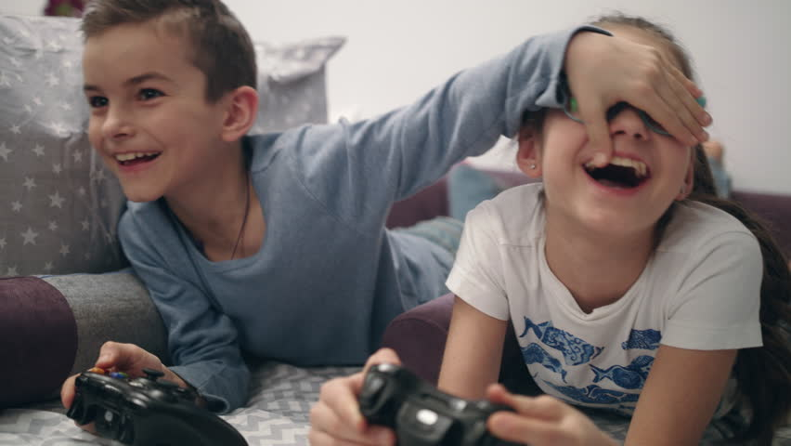
While too much screen time can be an issue for students, some games can help improve focus for students with disabilities such as attention-deficit/hyperactivity disorder, writes child psychologist Randy Kulman. Fast-paced video games such as "Plants vs. Zombies 2" help hone attention to detail and decision-making, Kulman writes.
Psychology Today 5/3/22
https://www.psychologytoday.com/us/blog/screen-play/202205/can-video-games-teach-kids-adhd-pay-attention
Image credit:
https://www.bing.com/images/search?view=detailV2&ccid=bTfYwsrl&id=96FB2E45A7F3779493D5DE495B9DBE8C08760FD1&thid=OIP.bTfYwsrlVKiAa9XTzS0feQHaEL&mediaurl=https%3a%2f%2fak1.picdn.net%2fshutterstock%2fvideos%2f1022857231%2fthumb%2f11.jpg&cdnurl=https%3a%2f%2fth.bing.com%2fth%2fid%2fR.6d37d8c2cae554a8806bd5d3cd2d1f79%3frik%3d0Q92CIy%252bnVtJ3g%26pid%3dImgRaw%26r%3d0&exph=480&expw=852&q=VIDEO+GAMES+AND+KIDS&simid=608036136705605030&FORM=IRPRST&ck=54DA36929791A2BB11A93458B201ABA0&selectedIndex=1&ajaxhist=0&ajaxserp=0

