Ad Fraud to Come with $16.4B Price Tag this Year
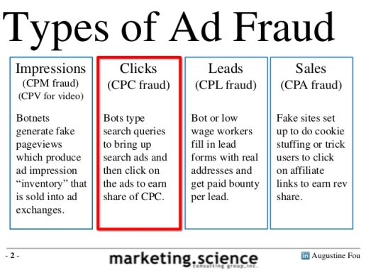
Ad fraud will cost advertisers an estimated $16.4 billion globally this year, according to The&Partnership, m/Six and Adloox. The&Partnership's Johnny Hornby has urged Google and Facebook to become part of industrywide third-party measurement efforts, saying, "The time has come for the Googles and Facebooks to stop marking their own homework."
The Drum (Glasgow, Scotland) 3/15/17
http://www.thedrum.com/news/2017/03/15/ad-fraud-may-cost-industry-164bn-2017-says-study-questions-continue-about-self
Image source:
http://image.slidesharecdn.com/searchadfraud101byaugustinefoutechnicalforensics-140212121433-phpapp02/95/search-ad-fraud-101-by-augustine-fou-technical-forensics-2-638.jpg?cb=1393398296

