Report: 10% of US Ad Sales Fraudulent
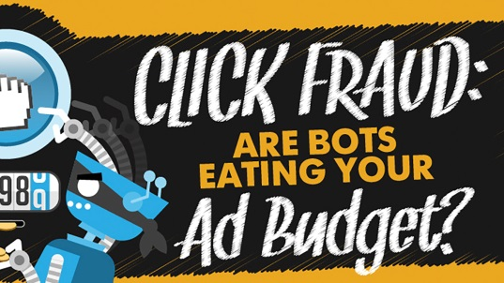
Ad fraud is costing global digital marketers $22.4 billion annually, with fraud accounting for 10% of US ad sales, or just under $2.5 billion, according to a GroupM report, even though major social platforms have been taking steps to enhance brand safety and thwart bot fraud. Mediatech Capital's Porter Bibb says the best way to overcome this issue is "third party (Nielsen-type) auditing of both content and count of ads actually delivered."
Broadcasting & Cable 9/9/19
https://www.broadcastingcable.com/news/groupm-puts-risk-of-ad-fraud-at-22-4b-globally
Image credit:
https://mompreneurmedia.com/wp-content/uploads/2016/10/How-Click-Fraud-Malware-Is-Making-Digital-Advertising-Costly.jpg?x79872

