Ad Groups Warn FCC that Privacy Rules will Hamper Innovation
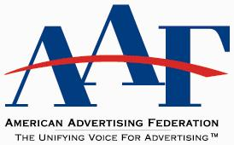
Ad industry groups including the American Advertising Federation, the Association of National Advertisers, the Interactive Advertising Bureau and the American Association of Advertising Agencies have stepped up opposition to the Federal Communications Commission's proposed privacy rules. The legislation "would undercut the competitive and innovative Internet marketplace, creating a negative impact on consumers," the groups wrote in a filing to the FCC.
MediaPost Communications 10/19/16
http://www.mediapost.com/publications/article/287220/ad-industry-tough-privacy-rules-will-undercut-i.html

