Adform Uncovers Fraudulent Ad Bot Stealing $500,000 Per Day
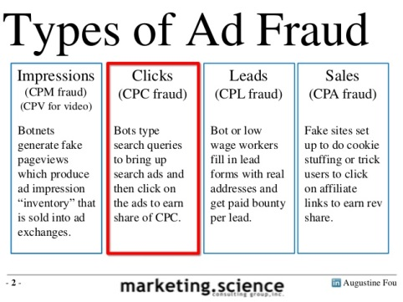
Adtech company Adform has announced the discovery of an advanced ad fraud scheme it has named "Hyphbot," which involves the creation of more than 1 million unique URLs and 34,000 domain names to trick advertisers into believing they're purchasing quality inventory from publishers such as CNN, The Economist and The Wall Street Journal.
The Drum (Scotland) 11/21/17
http://www.thedrum.com/news/2017/11/21/adform-claims-have-discovered-the-largest-bot-network-generating-over-15-billion
Image credit:
https://image.slidesharecdn.com/searchadfraud101byaugustinefoutechnicalforensics-140212121433-phpapp02/95/search-ad-fraud-101-by-augustine-fou-technical-forensics-2-638.jpg?cb=1393398296

