Advertisers Can Now Create 60-Second Spots on Instagram
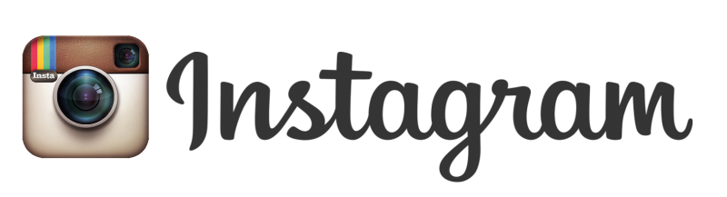
Instagram is enabling advertisers to create longer ads on the platform, extending the length from 15 seconds to 60 seconds. The length of time people spend on video consumption on the site has risen 40% since the middle of last year. "Strong creative and messaging can take the time it needs within the new 60-second window," iCrossing's Shannon Truax said.
Digiday.com 3/29/16
http://digiday.com/brands/longer-instagram-videos-mean-opportunity-work-agencies/

