Advertising Week Withdraws Support for Prince Andrew’s Pitch@Palace
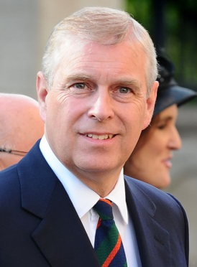
Advertising Week has confirmed that it no longer plans to support the Prince Andrew-backed tech initiative Pitch@Palace following his recent interview around his links to Jeffrey Epstein. Other sponsors to pull out of Pitch@Palace have included Cisco and KPMG, while others such as Barclays and Air Asia have declined to comment when asked whether they planned to continue to support the event.
The Drum 11.19.19
https://www.thedrum.com/news/2019/11/19/advertising-week-confirms-withdrawal-support-prince-andrew-s-pitchpalace?utm_campaign=Member_Update&utm_source=pardot&utm_medium=email
Image credit:
https://upload.wikimedia.org/wikipedia/commons/2/22/Prince_Andrew_August_2014_%28cropped%29.jpg

