AI and the Future of Brand Storytelling
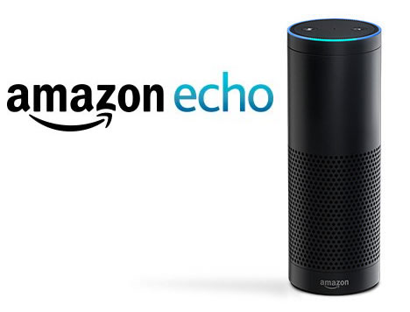
Brands looking to tell their stories are increasingly turning to artificial intelligence, creating a consumer experience that "had better be a good one," according to the annual "Interaction" report from GroupM. The report points to the popularity of Amazon's Echo and Google Home devices as evidence of the shift toward AI.
MediaPost Communications 2/6/17
http://www.mediapost.com/publications/article/294527/groupm-marketers-ignore-ai-at-their-peril-ad-fra.html

