Judge: There Is No Copyright On AI-Created Work
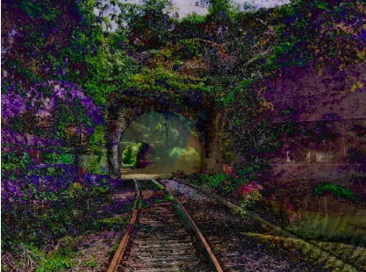
A US District Court Judge ruled that Stephen Thaler's AI-generated artwork could not be copyrighted as it lacked human authorship, even if Thaler created the AI algorithm himself. The judge wrote that copyright has never been given to something produced "absent any guiding human hand," adding that "human authorship is a bedrock requirement of copyright."
The Verge 8/19/23
https://www.theverge.com/2023/8/19/23838458/ai-generated-art-no-copyright-district-court
Image credit:
https://news.artnet.com/app/news-upload/2022/02/AI-Copyright-Thaler.jpg

