Artists' AI Suit Could Guide Other Creators
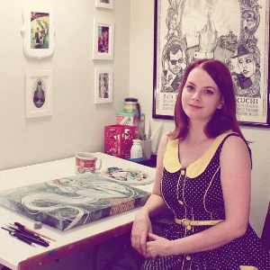
A group of three visual artists have filed a lawsuit against AI image generation toolmakers Stability A, Midjourney and DeviantArt, who they say are infringing on copyrights and profiting from their work. The case could provide insight into how successful other media creators could be in protecting their work from being used to train AI tools without permission or compensation.
NBC News 8/31/23
https://www.nbcnews.com/tech/tech-news/visual-artists-fight-back-ai-companies-repurposing-work-rcna102760
Image credit:
https://i.pinimg.com/originals/38/e1/7a/38e17a765df54ddb2a1dedc5535a6bc5.jpg

