Some Voice Actors Are Warming To AI Use
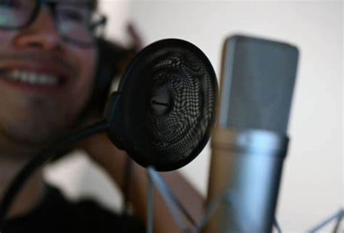
The use of AI technology to synthesize human voices remains a controversial subject among performers, but some voice actors are cautiously embracing AI to clean up recordings or change how old characters sound. Shreyas Nivas, CEO of Replica Studios -- which has signed a deal with SAG-AFTRA to create authorized digital replicas of some performers' voices -- says Replica is creating new revenue streams for actors rather than using AI to replace them.
The Associated Press 2/19/24
https://apnews.com/article/aigenerated-voice-clones-video-game-actors-replica-studios-sagaftra-517cc248f60a2f5e35f9b239b70f20a7
Image copyright:
https://1734811051.rsc.cdn77.org/data/images/full/443796/mexico-colombia-ai-media-locution.jpg?w=820

