How Southwest Can Overcome Its "Air-Mageddon"
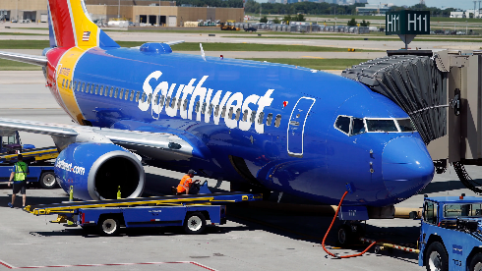
Southwest Airlines should consider taking steps to overcome its "air-mageddon" PR crisis driven by holiday flight cancellations, suggests Aaron Kwittken, CEO of PRophet. Kwittken suggests five possible actions for the airline including holding management accountable, endearing affected customers with free round-trip flight vouchers and even rebranding like "Wells Fargo did it when it 're-established' itself following a very distrustful run with consumers."
The Drum (free registration) 1.10.23
https://www.thedrum.com/opinion/2023/01/10/how-southwest-needs-handle-its-pr-crisis-and-save-it-s-soul
Image credit:
https://www.gannett-cdn.com/presto/2019/01/08/USAT/3a07bc99-9e9a-48fa-a2f8-c15b97b1d35c-AP_Earns_Southwest_Airlines_1.JPG?crop=4501,2532,x971,y1116&width=3200&height=1801&format=pjpg&auto=webp

