Alabama Public Television Refuses to Air Arthur Episode With Gay Wedding
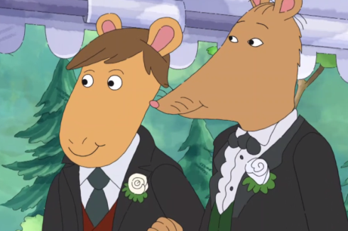
Alabama Public Television chose not to air PBS’s Arthur episode that included a same-sex marriage. In the episode, which aired nationwide May 13, Arthur and his friends attend their beloved teacher Mr. Ratburn’s nuptials to his partner. APT preempted the episode by showing a re-run of Arthur.
Alabama.com 5.20.19
https://www.al.com/news/2019/05/alabama-public-television-refuses-to-air-arthur-episode-with-gay-wedding.html?utm_source=Listrak&utm_medium=Email&utm_term=Alabama+Public+TV+Refuses+To+Air+%26%23039%3bArthur%26%23039%3b+Gay+Wedding+Episode&utm_campaign=Why+CBS+Isn%27t+Scared+Of+A+Streaming+War
Image credit:
https://www.indiewire.com/wp-content/uploads/2019/05/Screen-Shot-2019-05-13-at-2.14.18-PM-e1557780450834.png?w=780

