Wilson Does It Again
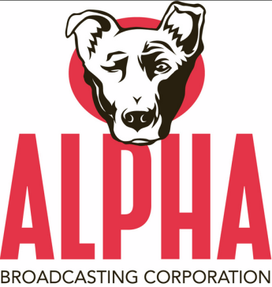
With the purchase of Digity's 116 stations, Larry Wilson's Alpha has become the fourth largest radio company in America by station count with 251. Only iHeartMedia (861), Cumulus (451) and Townsquare (315) have more stations. It also puts Alpha in third place in terms of number of markets with 54.
RadioInk 8.5.15

http://www.radioink.com/Article.asp?id=2958034&spid=30800

