Amazon Acquires MGM In $8.45B Deal
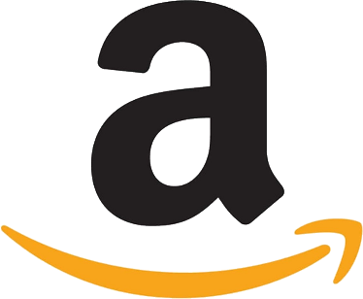
Amazon is purchasing MGM Holdings under a definitive agreement, priced at $8.45 billion, that will provide Prime Video with more than 17,000 shows and 4,000 movies. Discovery leader David Zaslav told a media conference the deal validates his company's $43 billion merger with WarnerMedia.
Variety 5/26/21
https://variety.com/2021/digital/news/amazon-buys-mgm-studio-behind-james-bond-for-8-45-billion-1234980526/

