Amazon Will Lead Big Tech Into Sports
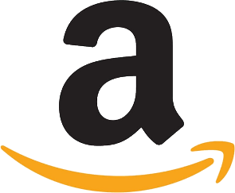
Amazon has already acquired the rights to stream soccer games in Germany and the UK and is seriously pursuing Thursday Night Football rights in the US. The entry of tech giants and social media platforms into sports broadcasting will put pressure on cable providers and regional sports networks, adds Maffei, whose Liberty Media owns the Atlanta Braves and Formula One racing.
The Hollywood Reporter 3.8.21
https://www.hollywoodreporter.com/news/liberty-media-ceo-sees-amazon-driving-big-techs-tv-sports-rights-ambitions

