Amazon App Adds AR Tool For Shoe Shopping
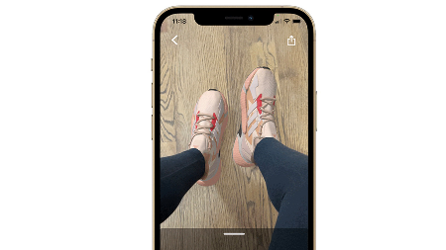
Amazon has introduced a new augmented reality feature on its shopping app that gives shoe buyers an idea of how different pairs of footwear will look on their feet. The Virtual Try-On for Shoes tool works with styles from brands including Reebok, Adidas and New Balance, according to Amazon.
CNBC 6/9/22
https://www.cnbc.com/2022/06/09/amazon-will-let-you-try-on-digital-versions-of-shoes-you-want-to-buy.html
Image credit:
https://www.the-sun.com/wp-content/uploads/sites/6/2022/06/RL-offplat-amazon-virtual-shoes.jpg?strip=all&quality=100&w=1920&h=1080&crop=1

