Amazon Prime Video Will Start Showing Ads Next Year
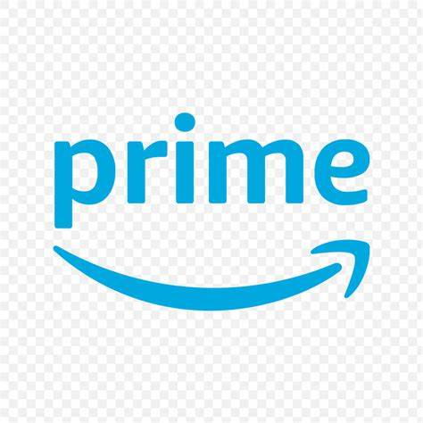
Ads are coming to Amazon Prime Video in early 2024 unless subscribers pay an additional $2.99 each month. The company cited the need to create "compelling content" when announcing the change and noted that it's trying to show ""meaningfully fewer ads" than other streaming providers.
StreamTV Insider 9/22/23
https://www.streamtvinsider.com/video/amazon-prime-video-latest-join-ad-supported-streaming

