Amazon to Stream NFL's "Thursday Night Football" Through 2019
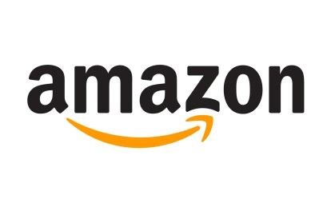
Amazon has signed a new agreement securing the NFL's "Thursday Night Football" rights through 2019. The tech company will reportedly pay $65 million per year to stream the next two seasons of Thursday night games.
Deadline Hollywood 4/26/18
http://deadline.com/2018/04/nfl-amazon-renew-thursday-night-streaming-deal-1202377756/

