American Cancer Society Unveils Multichannel Holiday Push
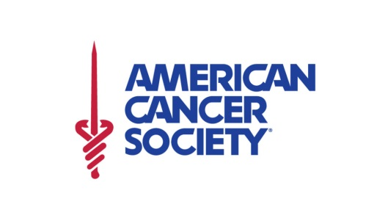
The Richards Group's new campaign for the American Cancer Society aims to boost fundraising during the holiday season with a series of spots that tell the stories of how real patients were helped by the organization. The push is running across digital, TV, print, social and radio including collaborations with DJ personalities on Westwood One and iHeartRadio.
MediaPost Communications 11/7/18
https://www.mediapost.com/publications/article/327727/cancer-society-richards-group-launch-plan-of-att.html
Plan Of Attack
https://www.youtube.com/watch?v=LAwm7gksWR0

