Americans Spent Over $5 Billion on Thanksgiving This Year
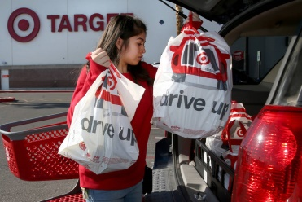
Figures outside of sales also hit new milestones. Nearly half (46.5%) of 2020 Thanksgiving purchases were made on smartphones, another record. And curbside pickup continued to be a draw for consumers, with retailers offering the service seeing a 31% higher conversion rate from traffic to their websites.
Ad Week 11.27.20
https://www.adweek.com/retail/hitting-record-highs-americans-spent-over-5-billion-on-thanksgiving-this-year/?utm_content=summary_component&utm_source=postup&utm_medium=email&utm_campaign=FirstThingsFirst_Newsletter_201130061502&lyt_id=1418028
Image credit:
https://www.reviewjournal.com/wp-content/uploads/2019/11/13032555_web1_CURBSIDE-NOV26-19_112519kc_015.jpg

