Americans Want Fake News to be Banned From the Internet
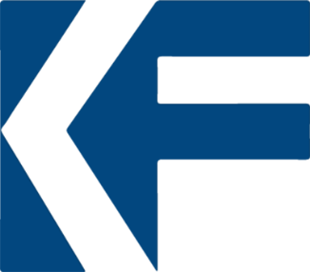
Majorities of U.S. adults say they are very concerned that major internet companies’ methods as a content arbitrator can give people a biased picture of the news, restrict the expression of certain viewpoints, and increase the influence of news that benefits the internet company and its preferred points of view.
Knight Foundation 8.15.18
https://www.knightfoundation.org/reports/major-internet-companies-as-news-editors?utm_source=API%20Need%20to%20Know%20newsletter&utm_campaign=c7bba25968-EMAIL_CAMPAIGN_2018_08_16_12_07&utm_medium=email&utm_term=0_e3bf78af04-c7bba25968-31697553

