An Auction That Could Transform Local Media (opinion)
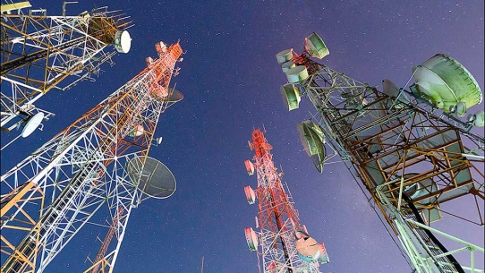
The proceeds from the FCC's incentive auction could produce enormous public benefits if they are used to build a 21st-century infrastructure for public interest media, writes Christopher J. Daggett of the Geraldine R. Dodge Foundation. A broad and exciting array of public interest initiatives, including digital news sites, blogs, podcasts, YouTube channels, public data sites, apps and civic engagement, could be built with some of the money generated by the auction.
The New York Times 11.28.16
http://www.nytimes.com/2016/11/28/opinion/an-auction-that-could-transform-local-media.html?action=click&pgtype=Homepage&clickSource=story-heading&module=opinion-c-col-left-region&region=opinion-c-col-left-region&WT.nav=opinion-c-col-left-region&_r=2
image source:
https://www.investors.com/wp-content/uploads/2016/06/SNAPpic060616.jpg

