AT&T's Stankey Calls Antitrust Concerns "Unfounded"
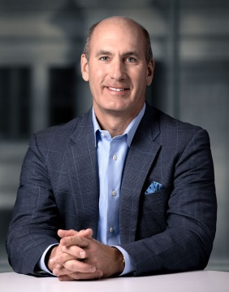
AT&T CEO John Stankey dismissed a call by some House Democrats for a Justice Department probe into the Discovery-WarnerMedia merger as "unfounded" and expressed confidence the deal would close in mid-2022. "From a regulatory-review perspective, there’s nothing unusual about this transaction," he told a UBS conference.
Variety 12/6/21
https://variety.com/2021/biz/news/att-ceo-unfounded-antitrust-democrats-letter-1235127269/
Image credit:
https://cdn.arstechnica.net/wp-content/uploads/2020/04/att-john-stankey.jpg

