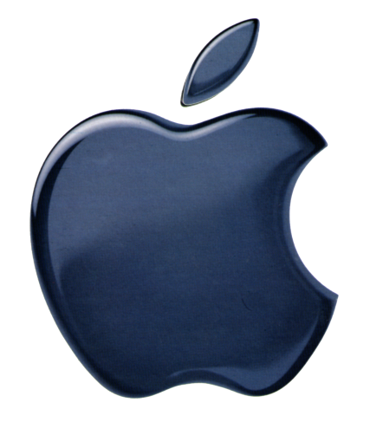
Apple Eyes Move into Original Programming
Apple has held preliminary conversations with Hollywood executives over producing original entertainment content in a move that may position it to compete with Netflix. The move could set up a showdown between Apple and Netflix, Amazon and Hulu.
Variety 9/1/15
http://variety.com/2015/digital/news/apple-eyes-move-into-original-programming-exclusive-1201582020/

