Apple Reportedly Has 'NFL Sunday Ticket' In The Bag
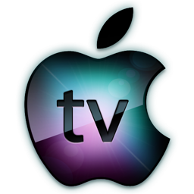
Apple has reportedly already won the bidding to pay more than $2 billion a year for the NFL Sunday Ticket games bundle and will assume control of the out-of-market regular season games package when it breaks free from the only television distribution partner it has ever had, DirecTV, starting in the 2023 season.
iMore 4/18/22
https://www.imore.com/apple-may-have-already-landed-nfl-sunday-ticket?utm_source=SmartBrief&utm_medium=email&utm_campaign=C74FC4FA-5D4D-4151-8915-3043BA411DBE&utm_content=1164EED8-61EA-424A-8BC7-56D7991DB72B&utm_term=a25693a1-51b6-4112-bde4-56bd420e983f

