Apple Reportedly Preps More Smart-Home Devices
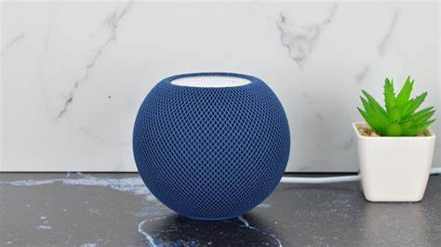
Apple is developing an array of smart-home devices, starting with a control tablet and eventually including a redesigned TV box with quicker processing, Bloomberg reports. The company introduced another HomePod model on January 18.
BNN Bloomberg (Canada) 1/18/23
https://www.bnnbloomberg.ca/apple-to-expand-smart-home-lineup-taking-on-amazon-and-google-1.1871903
image credit:
https://bgr.com/wp-content/uploads/2021/11/apple-homepod-mini-1.jpg?quality=82&strip=all?w=512

