Are Smartphones the New Remote?
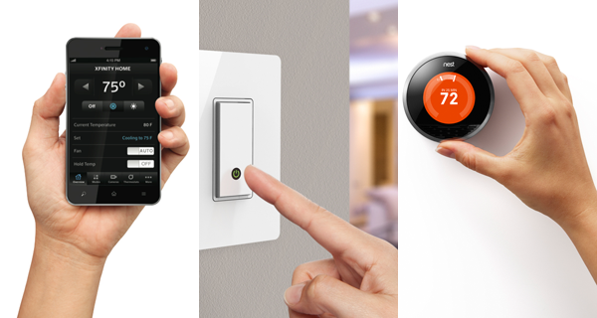
At least according to a recent study by GfK, which surveyed 1,000 U.S. internet users ages 18 and older. Fully 89% of respondents said they use their smartphone to control many of their home products and services. That's up 19 percentage points from 2015.
eMarketer 4.17.18
https://www.emarketer.com/content/are-smartphones-the-new-remote?ecid=NL1001
Image credit:
http://graphics8.nytimes.com/images/2013/03/28/technology/28toolkit-span/28toolkit-span-superJumbo.png

